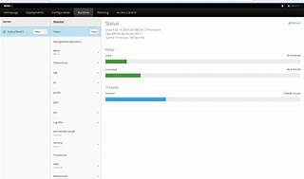

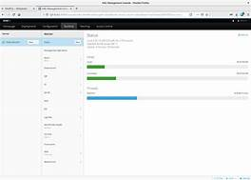

Explore

**WildFly**, formerly known as JBoss AS, is an **open-source application server** written in Java that implements the Java Platform, Enterprise Edition (Java EE) specification. [It provides a powerful, modular, and lightweight runtime environment for building and deploying Java applications1](https://en.wikipedia.org/wiki/WildFly).

Here are **five free reference links** where you can learn more about WildFly:

1. [**Getting Started Guide**](https://docs.wildfly.org/26/Getting_Started_Guide.html)[: This guide introduces you to WildFly 26, covering installation, configuration, and basic usage](https://en.wikipedia.org/wiki/WildFly)[2](https://docs.wildfly.org/26/Getting_Started_Guide.html).
2. [**WildFly Documentation**](https://docs.wildfly.org/30/)[: Explore installation options, administrative features, and more in the official WildFly documentation](https://en.wikipedia.org/wiki/WildFly)[3](https://docs.wildfly.org/30/).
3. [**What is a WildFly Server and What is it Used For?**](https://blog.servermania.com/wildfly-server)[: Learn about the server’s features and use cases in this article](https://en.wikipedia.org/wiki/WildFly)[4](https://blog.servermania.com/wildfly-server).
4. [**Administering the WildFly 8 Application Server**](https://www.learningpatterns.com/site/courseware/administering-the-wildfly-8-application-server)[: Dive deeper into management and administration topics](https://en.wikipedia.org/wiki/WildFly)[5](https://www.learningpatterns.com/site/courseware/administering-the-wildfly-8-application-server).
5. [**How to Deploy a Java App with the Wildfly Application Server**](https://thenewstack.io/how-to-deploy-a-java-app-with-the-wildfly-application-server/)[: A step-by-step tutorial on deploying Java applications with WildFly](https://en.wikipedia.org/wiki/WildFly)[6](https://thenewstack.io/how-to-deploy-a-java-app-with-the-wildfly-application-server/).

Happy learning! 🚀